# Setup to Connect to the Database Used by FlightGUI.exe

FlightGUI uses a SQLite database. Again, there may be other solutions, but the following works.

If you downloaded this from the git repository, the media files were also download. If you are doing this “stand alone”, start at this URL:

<http://www.ch-werner.de/sqliteodbc/>

Download both [sqliteodbc.exe](http://www.ch-werner.de/sqliteodbc/sqliteodbc.exe) *and* [sqliteodbc_dl.exe](http://www.ch-werner.de/sqliteodbc/sqliteodbc_dl.exe) as indicated.

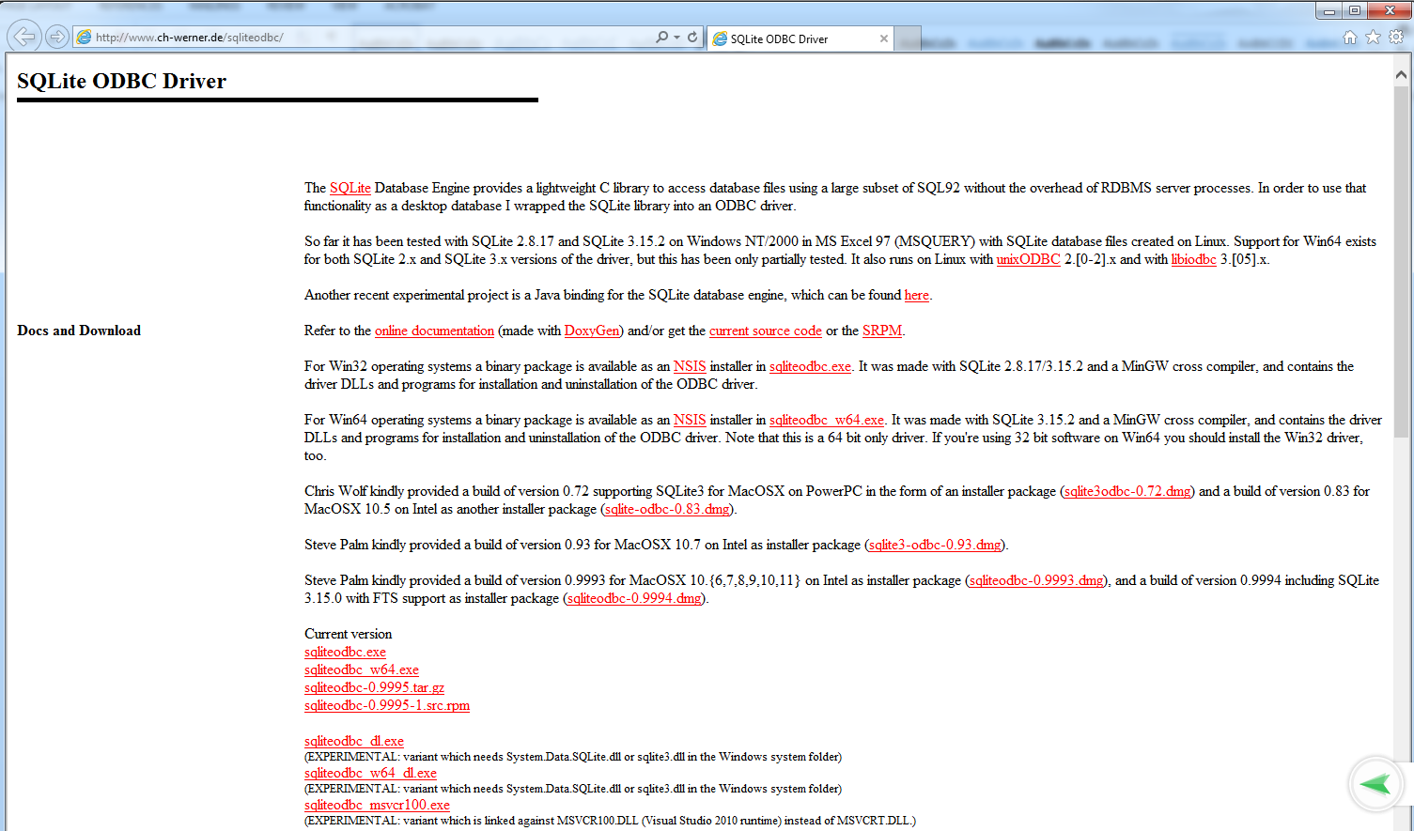



Similar to Oracle, they must both be placed, and run from the same directory. After placing, **you must run sqliteodbc_dll.exe first, then sqliteodbc.exe.**

You might want to also download a GUI tool to work with sqlite databases. One possible place is: xhttps://github.com/sqlitebrowser/sqlitebrowser/releases

Start the 32-bit ODBC Administrator (Section 1). (run:  %systemdrive%\Windows\SysWoW64\odbcad32.exe

In the ODBC Data Source Administrator (32-bit) window, click the Add button to add a data source. Scroll to the bottom. Choose SQLite3 ODBC driver, **not** SQLite (which is the 64-bit driver). Note that the screen shots below were done from a Windows 7 installation, so your screen might look slightly different.

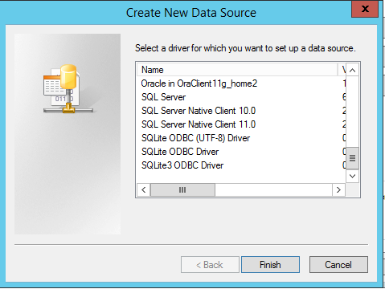

The following window appears.

* Note that the Data Source Name is hard coded in the script, so be sure to use exactly the string “Flight” as shown below
* The Database Name is probably

C:\Users\<your login>\AppData\Local\UFT\Demo\DB\Flights.s3db

But you should use the Browse control to verify

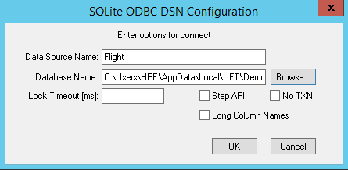

Note – within UFT, if you create a new database checkpoint or output value, within Microsoft Query, you will see:

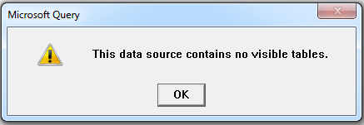

To fix this, hit OK, then select Options…

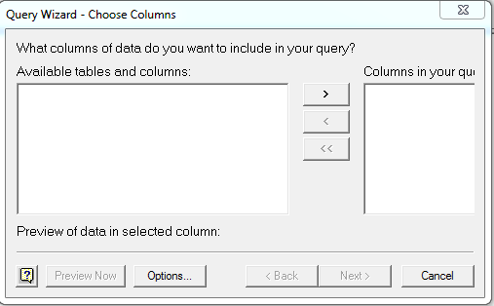

Enable System Tables by clicking the box

